Off-Field Assistant

- Title of the Project : Off-Field Assistant.
- Brief on the project: Selecting a balanced playing XI in the game of cricket with the right mix of players of different specialization is a difficult decision making problem for the team management. To make the process more objective, optimization techniques can be applied to the process of selection of players from a given squad. So the Aim of this project is to select or showcase a winning combination of best ‘suitable’ playing 11 players depending on the weather conditions, Opponent and the venue.
- Deliverables of the project:

- Player data collection and Individual player statistics analysis.
- Using the analysis for selecting the playing 11 considering
  - Player Evaluation
  - Opposition
  - Location/Ground Condition/Whether Condition
- Match Simulation using the player information.

- Resources
  - Data set source:
    - ESPN cric info :STATSGURU:
      - Player Perfomance data
      - Ground wise data
      - Player innings by innings Result Data.
  - Soft ware: Thinking of using R for now.

- References:

https://gigadom.wordpress.com/2015/07/04/introducing-cricketr-a-r-package-to-analyze-performances-of-cricketers/

http://www.cricmetric.com/blog/

- Team Members:

Name | Email-id | Mob
Siddhesh Sawant | sidd1886@gmail.com | 9870838697
Uddhav Patil | patil.uddhav26@gmail.com | 9769502447
Sanman Malvankar | malvankar.sanman@gmail.com | 8097188380
Jaivignesh | jaivignesh92@gmail.com | 9790028284
ABSTRACT

Cricket is an ideal sport to isolate individual team member contribution with respect to winning.This is due to the volume of digital data available, combined with the relatively isolated nature of the batsman versus bowler contest observed per ball. Like many other sports, Cricket is reliant on the contribution of interacting individuals causing fluctuations in match outcomes. Understanding the quantifiable causes of this variation can help interested parties derive insight into team success and potential strategies for optimising performance. Understanding the individual dynamic within the team setting can lead to improved team ratings. The objective of this research was to develop a roster-based system for limited overs cricket by deriving a team rating as a combination of individual ratings. The intent was to build an adaptive optimisation system that selects a cricket team of 11 players from a list of available players, such that the optimal team produces the greatest team rating.

Given the variety of numerical data generated by sports, it is paramount that meaningful information is extracted from the data. There is a breadth of academic literature
applying various statistical techniques to the world of sports.

RESEARCH MOTIVATION

There is a scarcity in literature surrounding team rating systems utilizing individual ability. This demonstrates a lack of demand and reflects a historical lack of access to data and computing resources. The primary objective was to develop a roster-based system for ODI cricket.

The intent is to derive a meaningful, overall team rating using a combination of individual ratings from a playing eleven. The goal was to build an adaptive rating system that selects a cricket team, based on a set of criteria, from a playing squad, such that the team rating reflects the best chance of winning.

For example if team A has a 15 ‘man’ squad the system should select a cricket team which maximizes the team’s overall rating, using individual ratings of the selected players, across a set of key roles and responsibilities. The optimal team was defined as the set of 11 individual players that produce the greatest probability of winning for team. This research centres on the development of an adaptive-predictive rating system, characterised by utilising past player performances, and accounting for the long and short term variability of a team’s performance. An adaptive method was preferred as it updates player and team ratings “based on historic performances upon availability of data about current performances.”

ACKNOWLEDGEMENT

With the help of our mentors Minta mam, Vinay Sir and Rajesh Sir and also with the help of the Internet we started our journey with a Capstone Project for Off-Field Assistant.
We are thankful to the Aegis Team for providing us ample time to spend on this project which in turn helped us made more familiar with R. We are thankful for the proper guidance provided by Vinay Sir and Rajesh Sir during our intermediate sessions.

DATA COLLECTION & WEB SCRAPING

The Data for all the cricket players has been collected by scraping the ESPNCricinfo’s STATSGURU website which maintains all the cricket data.
This data is collected for BATTING and BOWLING skills separately and analysed as per the purpose.

The data scrapped from STATSGURU is in two forms:

- Data of past two years to calculate the FORM of the player.
- Whole career data to find out the best player suitable with comparison to the above data set.

The data scrapped is in an Innings by Innings format along with the Game Result.

The Data is scraped for the whole INDIAN squad selected for the Tournament.

DATA CLEANING

A function has been created to remove unwanted data from the Raw Data obtained via Statsguru.

Player records such has DID NOT BAT or DID NOT BOWL and match results with the result as NO RESULT has been removed. Records like DNB and TDNB are removed with this function.

Also the Raw Data indicates Not Out records with an asterisk mark (*) which is removed for proper text processing in the Dataset.
Same way the missing Strike Rates are replaced with the averages.
Thus, we get a completely processed dataset.

PACKAGES

As R is the first language we have learnt in our course we have coded the project in R using various libraries provided in the CRAN repository of R.

Few of them are as listed below:

- magrittr
- dplyr
- scatterplot3d
- lubridate
- forecast
- XML
- randomForest
- corrplot
- caret
- ggplot2
- ggthemes
- stringr

METHODS and ALGORITHMS
We have used the basic method of creating player metrics and then ranking the players by creating the Performance Index.

Player Metrics are defined and calculated for Batting as well as Bowling category.

Later these metrics are analysed together to calculate the Performance Index of the
player.

This Performance Index is used to rank the players with respect to their skills.

Thus the Top players are selected as per the requirement in the Playing 11 of the Team.

These Player metrics are defined as per the player roles.
Ie: Bowler, Batsman, WK-Batsman.

Normalization function is used to normalize the data so that it can be used more efficiently.

The main Algorithm used here is Random Forest.

RandomForest is used along with all the defined metrics for Batting as well as Bowling.

Here features such as Playing Position, Number of Game Played, Total Runs , Total balls faced, Batting Average , Batting Strike Rate , Fours , Sixes , Total number of boundaries , Percentage of boundaries Hit, Total Dismissals and Total Wins are considered.

The ggplot library is utilized to plot the graphs related to various features of the Batsmen and Bowlers.

With the help of RandomForest we calculate the importance of the player which is a number. Higher the number , higher is the importance.

TECHNIQUES USED

- After creating the importance for Batsmen and Bowlers in the squad provided we calculate a number of things.

- Dataframes are created to calculate the index value of the players against the opposition using the whole career data.

- Dataframes are created to calculate the index values of the players using the current form i.e. the data set of past 2 years.

- These 3 indexes are combined to calculate the player value.

The final data frames are created at the end to define the players with respect to roles like Pure Batsman , WK Batsman , Bowling Allrounder and finally the Pure Bowler.

The final function PICKTEAM is created to finally select the final playing 11 players from the indexes ranking.

The Captain is selected irrespective of the records where as the above function works for remaining 10 players.

WK is selected after the captain depending if any WK is available in team more than one otherwise the same WK is selected.

Remaining players are selected as per the requirement and as per the Player Index Ranking.

GRAPHS and RESULTS

VIRAT KOHLI – RUNS SCORED vs No of 4s
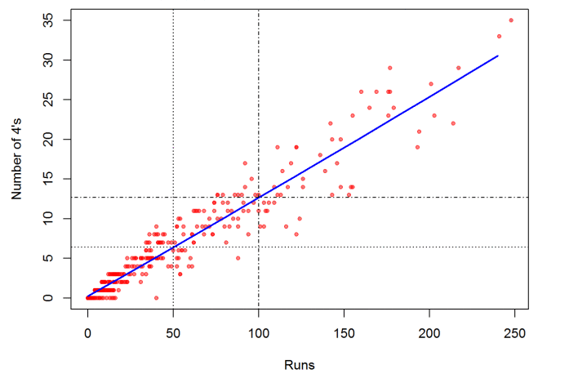

VIRAT – Pie Chart of Dismissals

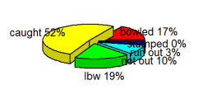

KOHLI’s AVERAGE RUNS At Ground

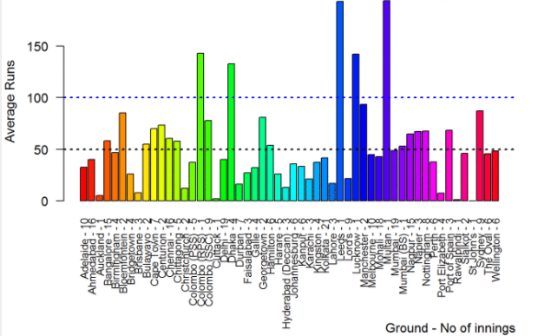

KOHLI AVERAGE vs OPPOSITION

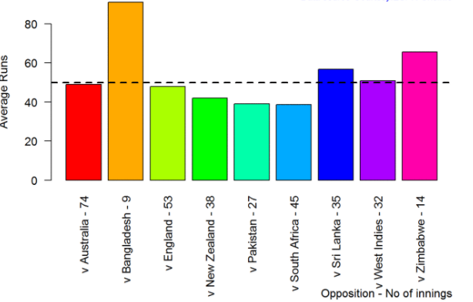

BATTING IMPORTANCE

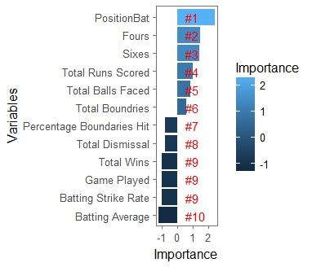

BOWLING IMPORTANCE

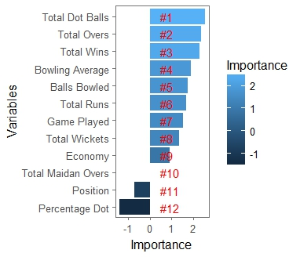

CONCLUSION

Thus with the help of STATSGURU , R and RandomForest algorithm we were able to analize the Best Winning Team for India against the given Opposition.

